

Revista Brasileira de Cartografia

ISSN 1808-0936 | <https://doi.org/10.14393/revbrascartogr>

Sociedade Brasileira de Cartografia, Geodésia, Fotogrametria e Sensoriamento Remoto

**Analysis of the Interdependence between Population Density and Vegetation in the São Paulo Metropolitan Region through Geoprocessing Techniques associated with Linear Regression**

Bruno Zomignani Perciani 1, Victor Fernandez Nascimento 2

1 Laboratório de Gestão de Riscos (LABGRIs), Universidade Federal do ABC (UFABC), Santo André, Brasil. bruno.perciani@aluno.ufabc.edu.br.

ORCID: <https://orcid.org/0009-0009-4558-6301>

2 Laboratório de Gestão de Riscos (LABGRIs), Universidade Federal do ABC (UFABC), Santo André, Brasil. victor.fernandez@ufabc.edu.br.

ORCID: [https://orcid.org/0000-0002-3311-8190](https://orcid.org/0000-0000-0000-0000)

Recebido: 10.2024 | Aceito: 11.2024

**Abstract:** Vegetation plays a fundamental role in mitigating urban environmental problems, contributing to reducing air pollution, controlling excessive heat and improving environmental quality, especially in megacities facing rapid growth and climate change. This study analyzed the relationship between population density and vegetation cover in the São Paulo Metropolitan Region (SPMR) using remote sensing, geoprocessing, and machine learning, with Landsat imagery (2000, 2010, 2022) and census data (2022). Results show non-linear behavior: NDVI decreases significantly with rising density only in low-density areas (PD < 47 Inhab/ha), while in medium- and high-density zones, vegetation is already scarce, and further densification has little impact. Priority areas combining high density and low NDVI were identified in both central and peripheral municipalities, highlighting the need for targeted policies such as urban parks, street tree planting, and vegetation restoration. The study demonstrates the relevance of remote sensing and machine learning for urban sustainability assessments, providing insights to guide evidence-based public policies that balance urban growth with environmental preservation, thereby fostering greener and more resilient cities.

**Keywords:** Remote Sensing; Artificial Intelligence; NDVI; Urban Sustainability; São Paulo Metropolitan Region.

# INTRODUCTION

Vegetation plays a crucial role in mitigating the adverse effects of the urban environment, such as air pollution, excessive heat, and land degradation, while providing tangible benefits, including improved air quality and increased humidity (Amato-Lourenço et al., 2016). This situation is exacerbated when considered in the context of climate change and its profound impact on the lives of living beings, particularly in densely populated areas (Martins, 2009). Therefore, studying and monitoring vegetation in urban areas is of utmost importance for the maintenance and understanding of vegetation cover behavior patterns in this type of environment (Duarte et al., 2018). Thus, remote sensing and geoprocessing techniques become essential allies in this process, as they provide the means for analyses to be conducted efficiently and at appropriate spatial and temporal scales (Ponzoni et al., 2012).

Moreover, it is worth noting that global climate change has exacerbated the challenges faced by metropolitan regions worldwide, such as the São Paulo Metropolitan Region (SPMR), intensifying extreme weather events, raising average temperatures, and altering rainfall patterns in the area (Li et al., 2017). These phenomena, in turn, have direct implications for the reflectance and distribution of vegetation in the region, affecting the dynamics of urban ecosystems and the quality of life of local populations (Sun et al., 2011). Thus, understanding the relationship between vegetation spectral indices and population in SPMR becomes crucial to guiding public policies and urban management practices that promote sustainability and resilience in the face of climate change, since vegetation distribution in urban environments emerges as an essential metric to assess environmental quality and human well-being in cities (De La Iglesia Martinez & Labib, 2023).

As mentioned earlier, remote sensing and geoprocessing techniques play a supporting role in urban and territorial planning, allowing for the exploration of the relationship between urban vegetation spectral indices and demographic data in metropolitan regions. The Normalized Difference Vegetation Index (NDVI), for example, is a widely used spectral index for assessing vegetation cover in each area (Ponzoni et al., 2012). Studies usually indicate an inverse relationship between Population Density (PD) and NDVI samples, especially in urban regions. This behavior is observed because in areas with high PD, urban sprawl tends to reduce vegetation cover, resulting in lower NDVI values. Conversely, regions with lower PD generally preserve more green areas, presenting higher NDVI values. Cerqueira and Gomes (2020) analyzed NDVI in municipalities of Piauí and Ceará engaged in carnauba wax extraction. The results showed that vegetation suppression in some locations was deeply associated with increased urbanization or productive scale, suggesting a correlation between PD and reduced vegetation cover.

A practical application of geoprocessing techniques for territorial and urban planning was developed by Gupta et al. (2012). In this study, the Urban Neighborhood Green Index (UNGI) was presented as a tool developed to assess the quantity and quality of green spaces in urban neighborhoods, considering vegetation density, residents’ accessibility to green spaces, proportion of built-up areas relative to total space, and structure height as the main parameters of analysis. From this index, it was possible to identify areas in need of improvement in green spaces in New Delhi neighborhoods, helping urban planners and municipal managers implement actions that promote environmental quality and residents’ well-being. The use of remote sensing in urban analyses contributes to a more holistic understanding of ecological processes and ecosystem behavior in densely populated areas, providing knowledge for informed decision-making and the promotion of greener, healthier, and more resilient cities (Gupta et al*.*, 2012).

Therefore, the goal of this study is, through remote sensing, geoprocessing, and linear regression techniques, to validate whether the correlation pattern observed between vegetation and population dynamics in other studies also occurs in the SPMR, as well as to identify high priority areas for implementation of sustainable and green public policies. Consequently, the specific objectives of this study are: (I) to qualitatively assess the evolution of average NDVI and Land Use and Land Cover (LULC) in the urban areas of the SPMR for the years 2000, 2010, and 2022; (II) to quantitatively examine the relationship between NDVI and PD in SPMR using linear regression for the years 2010 and 2022; and (III) to identify high‑priority areas for the implementation of public policies aimed at restoring urban vegetation fragments based on 2022 data, thereby promoting sustainable urban planning and enabling the efficient allocation of resources for the creation of new green elements in regions most affected by fast urbanization. It is expected that lower NDVI values will be found in areas of higher PD, given the trend that more populated regions contain fewer areas of native vegetation.

# STUDY AREA CHARACTERIZATION

The SPMR, comprising of 39 municipalities (Figure 1), represents one of the most complex urban conglomerates in Latin America and worldwide. It is the largest metropolitan region in Brazil, characterized by a dense concentration of human activities, unrestrained urban expansion, rapid industrial development, and a constantly growing population (Nobre et al., 2011). According to the Brazilian Institute of Geography and Statistics (IBGE), the SPMR has approximately 20,743,587 inhabitants distributed over a total area of 7,944 km², resulting in an average PD of over 2,600 inhabitants per km². However, in central and smaller districts, this value may be significantly higher.

The intense urbanization process assessed has been accompanied by profound environmental changes, including the reduction of native vegetation (Seto et al., 2012; McDonald et al., 2008), soil sealing (Yuan & Bauer, 2007), and the intensification of urban heat islands presence (Oke, 1982; Arnfield, 2003). Originally covered by the Atlantic Forest biome, the SPMR still preserves remnants, mainly in peripheral municipalities and in protected areas such as Cantareira State Park and Serra do Mar State Park. However, these forest fragments are under constant pressure from real estate expansion, road infrastructure development, and irregular occupation (Ribeiro et al., 2009; Nobre, 2011).

From a socioeconomic perspective, the SPMR is the main Brazilian financial, industrial, and cultural hub, generating a significant portion of the national Gross Domestic Product. This strong concentration of economic activity, however, also intensifies social inequalities and environmental vulnerabilities. While wealthier districts preserve more urban green areas, peripheral and densely populated neighborhoods suffer from a lack of vegetation cover and higher exposure to both environmental and climatic risks (De La Iglesia Martinez & Labib, 2023).

Therefore, the SPMR constitutes a complex laboratory for studying the interactions between urbanization, vegetation, and climate change. Its magnitude, diversity of land use, and socio-environmental contrasts make it a relevant case study for understanding the dynamics of urban ecosystems in megacities of the Global South. In this context, vegetation monitoring emerges as a crucial tool for guiding sustainable urban management and mitigating the negative impacts of urban expansion in climate.

Figure 1 – Location of the Metropolitan Region of São Paulo (SPMR).

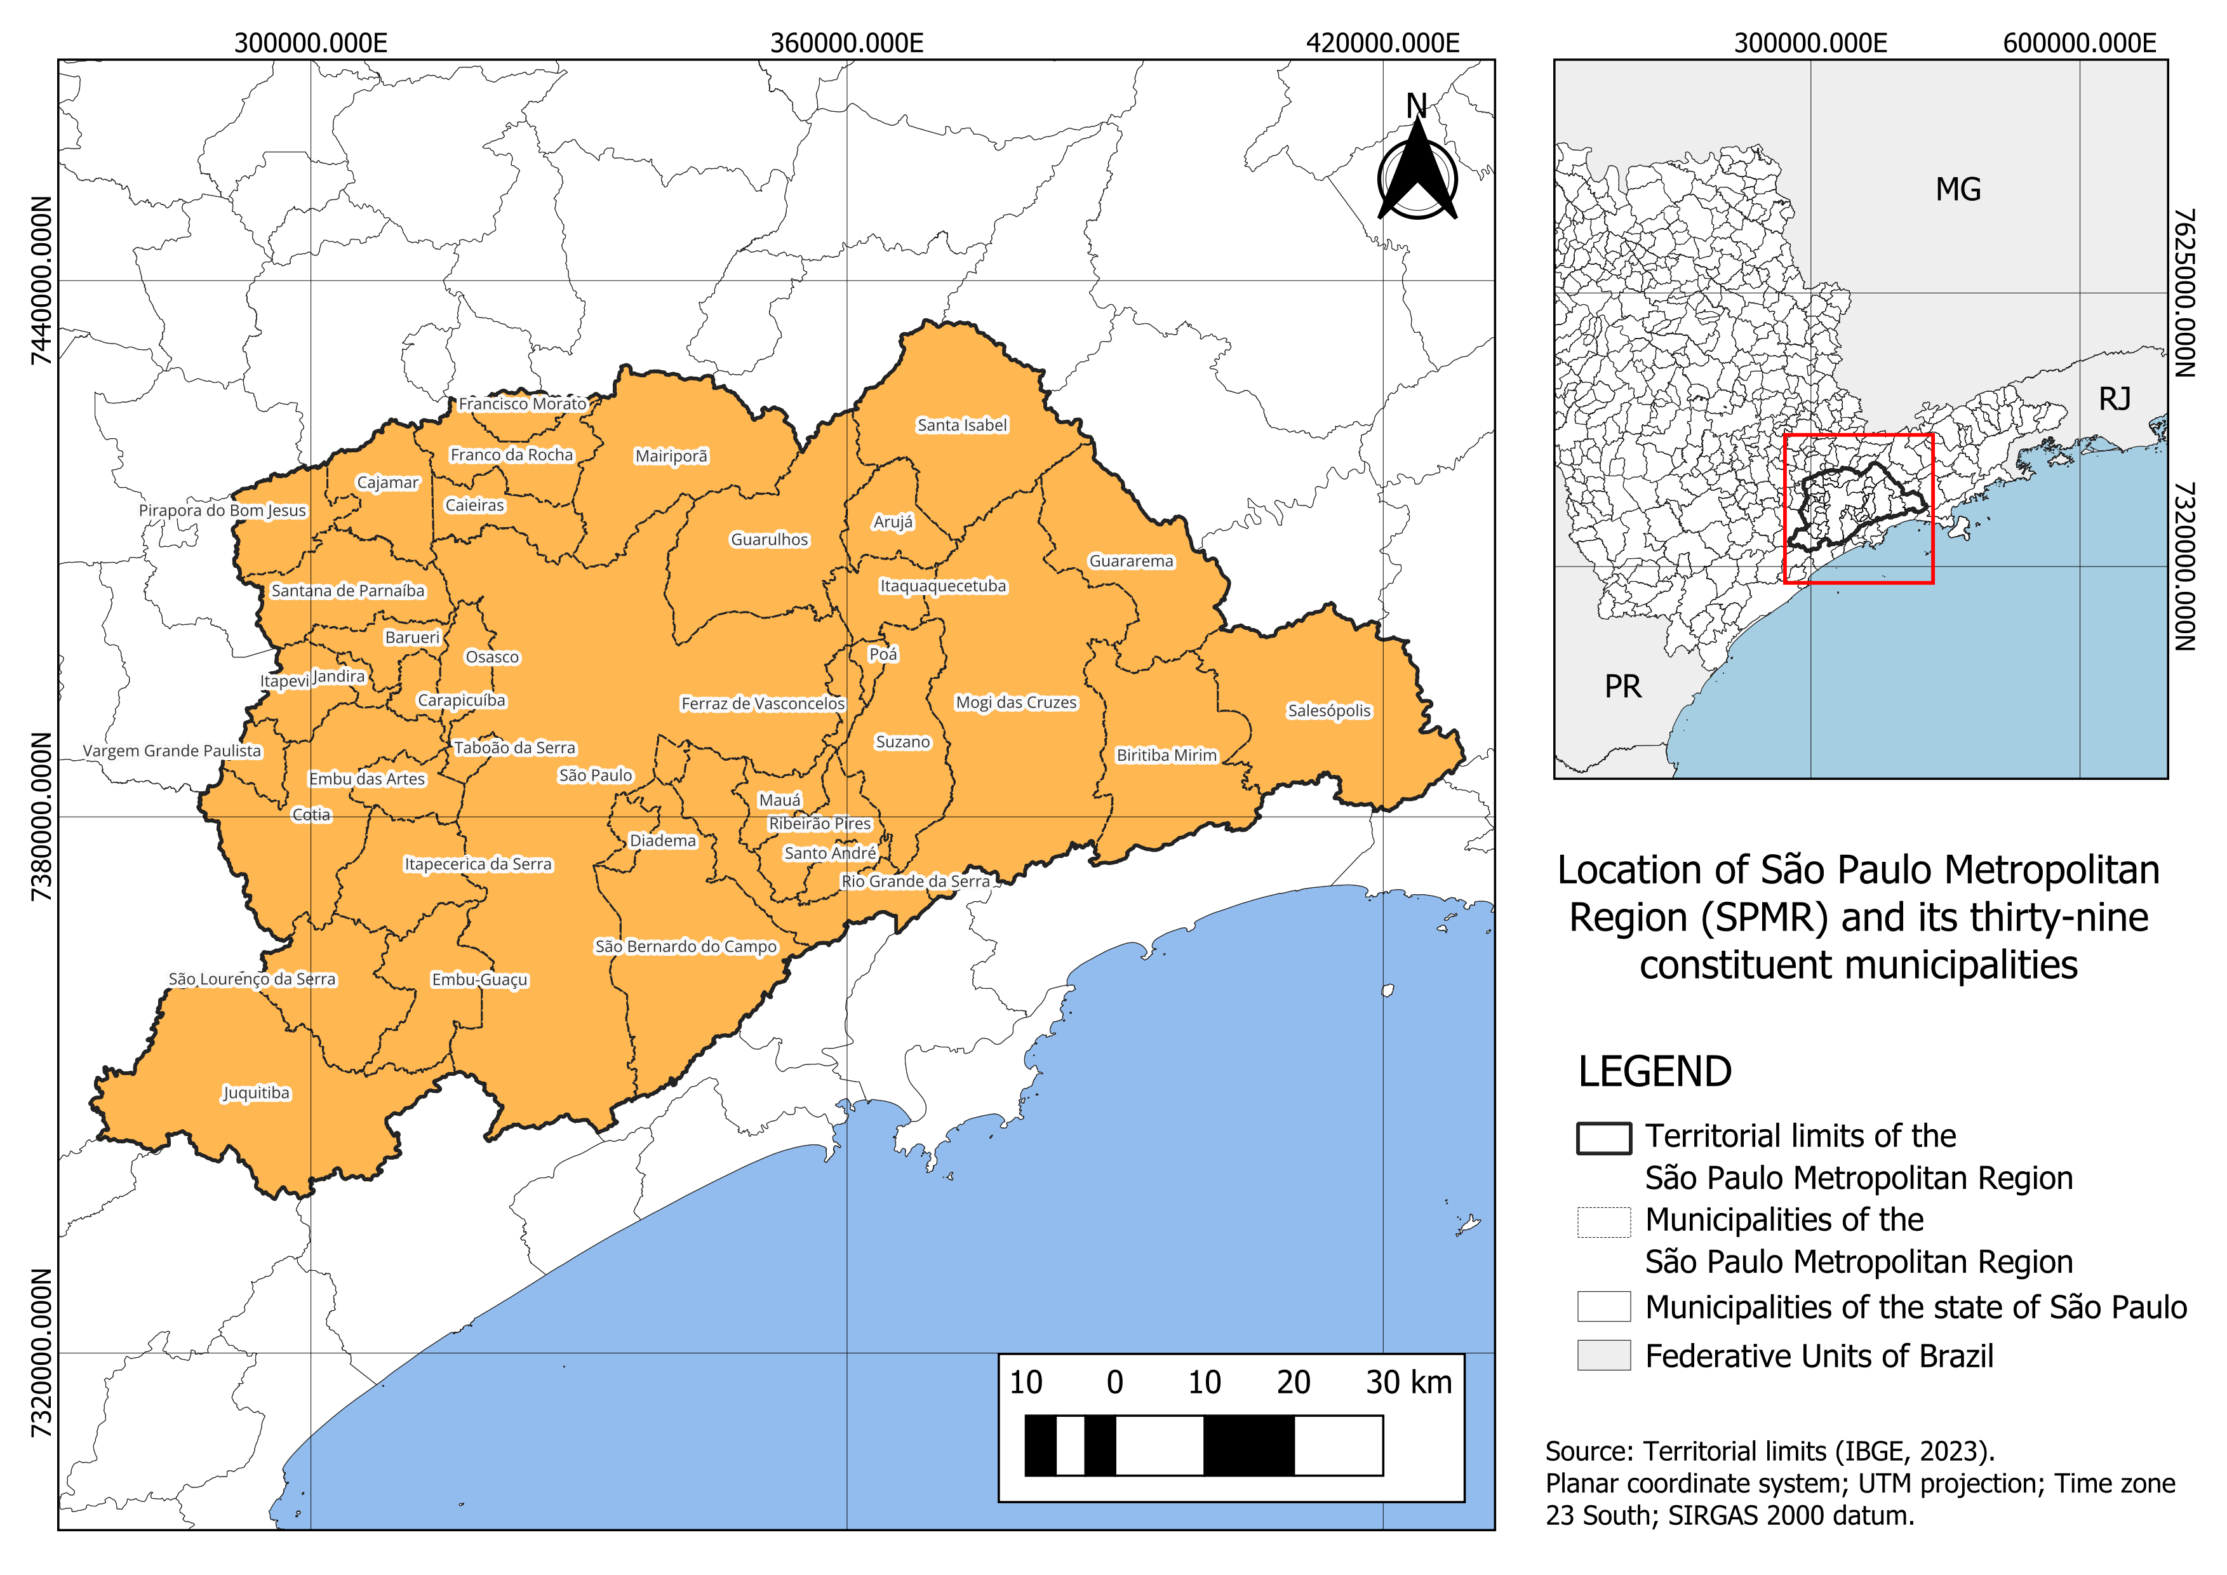

Source: The authors (2025).

# METHODOLOGY

The present study adopted a remote sensing and geoprocessing workflow to conduct a temporal analysis of vegetation dynamics in SPMR (Figure 2). The chosen approach follows the framework of Ponzoni et al. (2012), combining (I) qualitative procedures, including image interpretation and GIS integration, and (II) quantitative procedures, primarily the derivation and statistical analysis of vegetation spectral indices. In line with Gupta et al. (2012), this research design also employs mixed data usage, integrating satellite-derived vegetation information with demographic indicators to examine the relationship between urban vegetation patterns and population distribution throughout the study area.

Thereupon, territorial limits were established using IBGE administrative boundaries, which provided the spatial framework for all processing steps. Within these limits, the workflow proceeds through sequential phases: the compilation and processing of multi‑date satellite imagery, followed by the collection of LULC data and the generation of annual average NDVI for the years 2000, 2010, and 2022; the collection of population data from the 2010 and 2022 IBGE censuses and the calculation of the population density (PD) surface; the spatial alignment and sampling of NDVI and PD values on a regular point grid covering the entire SPMR; and the statistical assessment of the NDVI–PD relationship by PD intervals using linear regression for descriptive trend analysis. Building on these results, the method involved reclassifying NDVI and PD into three classes each and constructing a priority matrix using 2022 data, adapted from the logic employed by Gupta et al. (2012), to identify areas of high, medium, and low priority for public policy action.

Figure 2 – Methodological workflow for the research objectives.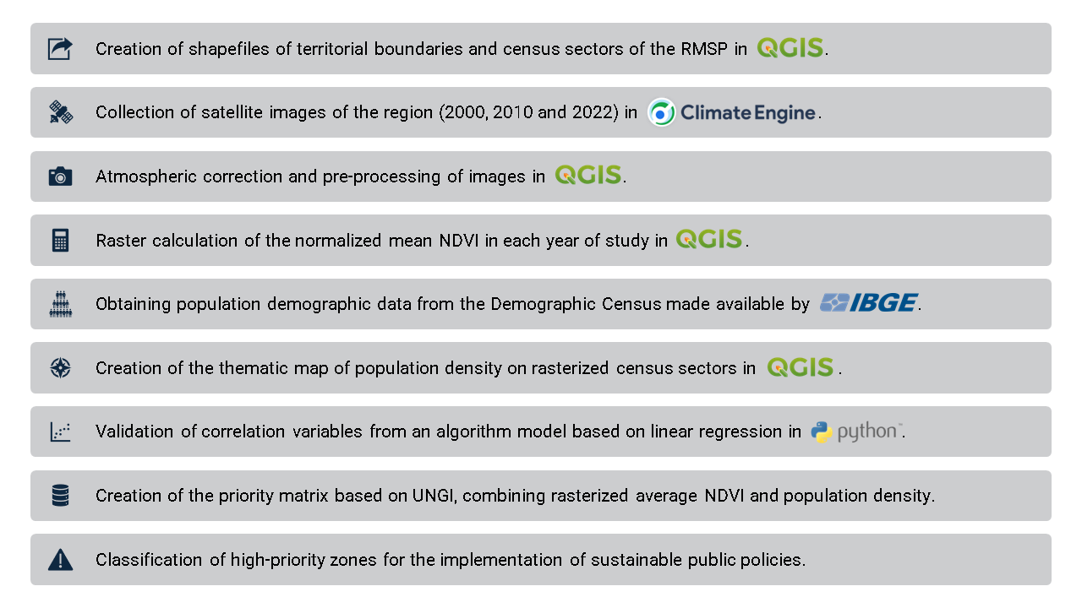

Source: The authors (2025).

## Data used

As described in advance, this study relied on a combination of remote sensing, demographic, and LULC data to enable an integrated analysis of vegetation and population dynamics across SPMR. The selected datasets were chosen based on their availability, reliability, and suitability for long-term temporal analysis at a metropolitan scale (Table 1). Remote sensing imagery was obtained from the Climate Engine platform, which allows access to Google Earth Engine (GEE) datasets and enables cloud-based processing of extensive satellite archives (Huntington et al., 2017). Landsat imagery with a 30-meter spatial resolution was used for the three reference years cited.

Table 1 – Description of the geospatial and demographic data used in the study.

| **Data type** | **Source** | **Time span** | **Spatial resolution** | **Temporal resolution** | **Format / Access** |
| --- | --- | --- | --- | --- | --- |
| Landsat-7 ETM+ imagery | Climate Engine (via GEE) | 2000, 2010 | 30 m | Annual average composites | Raster / Cloud platform |
| Landsat-9 OLI-2 imagery | Climate Engine (via GEE) | 2022 | 30 m | Annual average composites | Raster / Cloud platform |
| Administrative boundaries | IBGE | — | Municipal and census tract polygons | Static | Shapefile / IBGE |
| Demographic data | IBGE | 2022, 2010 | Population tables | Decennial | Vector / IBGE |
| LULC | MapBiomas, Collection 9 | 2000, 2010, 2022 | 30 m | Annual maps | Raster / Cloud platform |

Source: The authors (2025).

Demographic information was sourced from IBGE where data were structured at the census-tract level, enabling precise calculation of PD. Besides, the administrative boundaries of SPMR were incorporated from IBGE vector shapefiles, which served as the spatial reference framework for clipping, integration, and analysis of all datasets collected. To complement, LULC data were retrieved from the MapBiomas Project, Collection 9, which provides consistent classifications of Brazilian land usage from 1985 to 2022. For this study, five main classes were derived: native vegetation, agriculture and pasture, urban areas, water bodies, and others.

To enhance transparency and reproducibility, the Python script used for the linear regression analysis, along with samples of the processed dataset, are made available in a dedicated GitHub repository. Readers are encouraged to consult this repository for access to the code and data samples used in this study, available at: <https://github.com/BrunoPerciani/regiao-metropolitana-de-sao-paulo>.

## Methods

As aforementioned, the methodological approach of this study was designed to integrate remote sensing, geoprocessing, and statistical techniques with census data in SPMR, as also conducted by Li and Weng in Indianapolis (2007). The process can be summarized in five main stages: (I) processing of satellite imagery and NDVI generation, (II) demographic data processing and derivation of PD surfaces, (III) correlation and regression analysis of NDVI–PD interactions, (IV) spatial reclassification to identify priority zones for sustainable policy implementation and (V) LULC integration to contextualize the NDVI and population density analysis.

### processing of satellite imagery and NDVI generation

Satellite imagery was obtained through Climate Engine platform, a cloud-based system that enables visualization and processing of climate and remote sensing data (Huntington et al., 2017). Its main advantage lies in the ability to process large volumes of data without local infrastructure, making it suitable for real-time environmental monitoring. The platform relies on Google Cloud and GEE which allow on-demand processing of satellite and climate datasets directly in a web browser.

Thus, remote sensing data from the SPMR were acquired for the years 2000, 2010, and 2022, with a spatial resolution of 30 meters. Consequently, as emphasized by Sharma et al. (2024), QGIS is an integrated platform for remote sensing analysis, enabling the combination of geospatial datasets with advanced processing tools. Just like in their study, QGIS was applied to conduct essential spatial analyses that supported natural resource management, demonstrating its capability to incorporate remote‑sensing‑derived information and strengthen environmental decision‑making processes.

Accordingly, image pre-processing and atmospheric correction were carried out, as also performed by Moravec et al. (2021). Subsequently, raster calculations of NDVI and PD were conducted. According to Eastman et al. (2013), although NDVI presents certain limitations, it is widely used in environmental studies due to its ability to quantify vegetation density and vigor. This index is based on the reflectance difference between the near-infrared (NIR) and red (RED) spectral bands. Values close to 1 indicate the presence of vegetation, characterized by high NIR reflectance and low RED reflectance. Thus, NDVI was calculated using the equation (1):

|  |  |  |
| --- | --- | --- |
|  | $$NDVI=\frac{NIR-RED}{NIR+RED}$$ | (1) |

As stated by Eastman et al. (2013), some of the main applications of NDVI, adopted in this study, include the detection of environmental changes by identifying areas affected by deforestation, wildfires, or drought, for example. It must be emphasized that the final value obtained corresponds to the annual average NDVI for each year under analysis, to minimize seasonal effects caused by changes in climate and seasonality, thereby ensuring greater accuracy of the results. The use of annual composites was made possible through the Climate Engine’s cloud processing, which enables the generation of average reflectance across time windows (Huntington et al., 2017). This approach was essential once seasonal variation may produce distortions when comparing vegetation cover over long periods.

### Population density mapping

Subsequently, for the PD analysis (Figure 3), demographic data was obtained from IBGE Demographic Census for the years 2010 and 2022. In QGIS, demographic data from the alphanumeric census population table were joined to the census tract shapefile table via SQL commands, using the census tract ID as the primary key. The "Field Calculator" tool was employed to compute the area of each census tract in both square meters and hectares. PD per unit area was then derived by dividing the population count (Column V002) by the area in hectares, as expressed in equation (2):

|  |  |  |
| --- | --- | --- |
|  | $$DP=\frac{Population}{Area (Hectares)}$$ | (2) |

After the computation, vectors were classified and symbolized using a quartile‑based scheme, which divides the dataset into classes of equal count according to the distribution of values. Subsequently, this vector file was converted into a raster layer using the “Vector to Raster” tool to ensure spatial accuracy, facilitate the analysis of population distribution patterns across the study area, and enable statistical calculations on the resulting data. This procedure is consistent with the approach developed by Santos et al. (2018), who examined population density patterns in Aparecida de Goiânia by integrating census data at the sector level with geospatial analysis. To achieve this, the authors processed IBGE demographic information within a GIS environment and produced detailed cartographic outputs derived from orbital and suborbital imagery.

Figure 3 –Data processing workflow for the PD derivation for 2010 and 2022.

Source: The authors (2025).

### Statistical correlation and regression analysis

In due course, to validate the pattern reported in previous studies, the relationship between NDVI and PD was examined through a linear regression model applied to the years 2010 and 2022. To enable the sampling of values for both variables, a point grid for the SPMR was generated using the “Create Grid” tool, with a spacing of 250 meters between points. Then, the “Sample Raster Values” tool was used to extract NDVI and PD values, which were appended as new columns in the attribute table of the point vector layer. The resulting dataset was exported as CSV files containing the fields “NDVI”, “PD”, and the geographic coordinates of each sampling point.

Pre-processing of the result datasets was conducted in Python using the libraries *pandas*, *numpy*, *SciPy*, *scikit‑learn*, and *matplotlib*. The steps included: (I) removing null or infinite values; (II) constraining NDVI values to the physical interval [−1, 1] and (III) excluding records with PD = 0. Also, to account for differences in urbanization intensity the PD dataset was stratified into three classes (Table 2), thus, bringing three correlation results for both 2010 and 2022 years.

Within each class, the NDVI–PD association was quantified using two correlation measures: *Pearson’s* r, for linear relationships, *Spearman’s* ρ, for monotonic associations less sensitive to non-linearities. Significance was tested using a two-tailed test at α = 0.05. Additionally, a linear regression line (OLS) fits within each stratum, serving only as a descriptive trend and not for causal inference or prediction. Results were presented in scatterplots with standardized axes, regression lines, and Pearson coefficients displayed directly on the plots. Then, a summary table with sample size (n), *Pearson’s* r and p, *Spearman’s* ρ and p was automatically generated.

This approach aligns with the methodology presented by Carvalho Júnior et al. (2005), who applied simple linear regression to correlate hyperspectral spectral signatures with the occurrence of specific minerals. Furthermore, the procedure adopted was also inspired by Junttila & Laine (2017), who employed a more advanced linear regression framework to investigate the relationship between forest structural variables and metrics derived from remote sensing data. The combination of these methods enabled the identification of NDVI–PD trends within SPMR and supported the assessment of whether the observed patterns were consistent or exhibited statistically significant differences.

### Reclassification and priority mapping

To categorize priority zones for the implementation of sustainable public policies, it was first necessary to reclassify both NDVI and PD into interpretable and operational variables (Table 2). NDVI was reclassified into three classes: (I) low (NDVI < 0.3), representing areas with potentially reduced vegetation presence; (II) medium (0.3 ≤ NDVI < 0.6), indicating areas with moderate vegetation presence; and (III) high (NDVI ≥ 0.6), corresponding to areas with greater vegetation presence. Similarly, PD was reclassified into three categories, (I) low (PD < 47); (II) medium (47 ≤ PD < 95); and (III) high (PD ≥ 95), representing different levels of human occupation within each census tract. This transformation converted continuous raster values into discrete classes, enabling their subsequent logical combination with NDVI.

Table 2 – Reclassification of NDVI and PD into operational variables in SPMR.

| **Average NDVI reclassification intervals** | **Value** | **Reclassification description** |
| --- | --- | --- |
| NDVI < 0.3 | 1 | Low NDVI |
| 0.3 ≤ NDVI < 0.6 | 2 | Medium NDVI |
| NDVI ≥ 0.6 | 3 | High NDVI |
| **PD reclassification intervals** | **Value** | **Reclassification description** |
| PD < 47 | 1 | Low population density |
| 47 ≤ PD < 95 | 2 | Medium population density |
| PD ≥ 95 | 3 | High population density |

Source: The authors (2025).

The reclassification scheme was applied both to generate the NDVI–PD priority matrix used to identify areas requiring public policy intervention and to standardize the PD dataset employed in the previously described linear correlation analysis, thereby ensuring methodological consistency across both procedures.

It is important to emphasize that the definition of the population density reclassification intervals was based on the SPMR specific context. Rather than applying absolute global thresholds distinguishing rural and urban zones, as often seen in international studies, an internal stratification was chosen—more sensitive to the spatial variations in density within the metropolitan region itself. This choice draws on the work of Pozzi and Small (2002), who, when analyzing vegetation in urban and suburban areas in the United States, demonstrated that population densities above 4,000 to 5,000 inhabitants/km² (equivalent to 40 to 50 inhabitants per hectare) already represent compact urban areas with reduced vegetation cover. Similarly, Bai (2019), when mapping population density in China using remote sensing data, identified the same interval as typical of consolidated urbanized regions. Furthermore, some international guidelines, such as those from the United Nations (UNStat, 2017) and the European Commission (Eurostat, 2011), also adopt values close to 50 inhabitants per hectare as a reference for continuous urban zones characterized by high concentrations of buildings and infrastructure, in contrast to less dense or rural areas.

In this context, NDVI reclassification into three ranges was also supported by studies that use similar thresholds to represent different levels of vegetation cover, particularly in urban environments. According to Tucker (1979), NDVI values below 0.3 are typical of areas with little or no vegetation, such as built-up surfaces, bare soil, and water bodies. This interpretation is reinforced by Weier and Herring (2000, NASA), who noted that urban regions and bare soils often present values between 0 and 0.2. The intermediate range of 0.3 to 0.6 is widely recognized as representative of sparse or moderate vegetation. For example, Zhang F. *et al*. (2018), in a study on Chinese megacities, considered this range indicative of areas with heterogeneous vegetation cover, such as urban parks, grasslands, and small tree fragments. Finally, NDVI values above 0.6 denote dense vegetation, such as forest cover, environmental protection areas, or urban regions with consolidated tree canopy. This approach was also adopted by Guo *et al*. (2019) to classify high-vegetation zones in large Chinese cities.

Next, a priority matrix was constructed (Figure 4) to establish the combinations between NDVI and population density classes. This matrix was inspired by the Urban Green Infrastructure (UNGI) matrix applied by Gupta *et al*. (2012) but adapted to the context of this study. As in the original model, areas with low NDVI and high population density were classified as “High priority” because they represent critical zones requiring stronger interventions to balance vegetation and urban occupation. Areas with high NDVI and low population density were classified as “Low Priority,” since they already display a more balanced condition. Other combinations were categorized as “Medium priority.”

Figure 4 – Priority matrix for the implementation of sustainable public policies based on NDVI and PD.

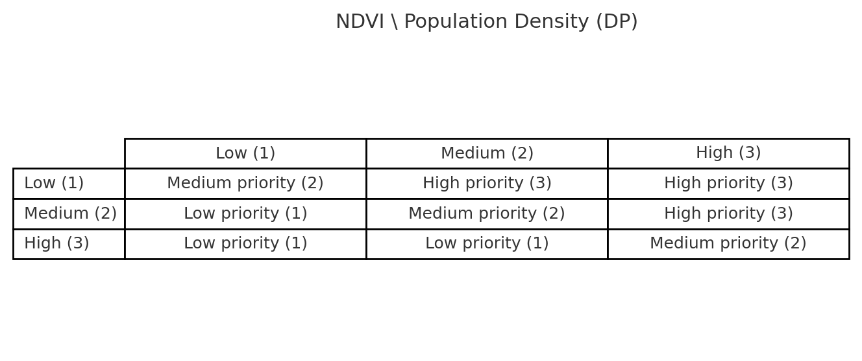

Source: The authors (2025).

To implement this priority matrix, the equation (3) was applied in the raster calculator in QGIS. This formula multiplies NDVI values by a factor and sums them with the population density values, resulting in unique codes for each combination. A new raster was thus generated, combining the reclassified values of mean NDVI and population density. This combined raster was subsequently reclassified according to the defined priority matrix (Table 2), assigning numerical values that represented the final categories. Finally, the reclassified raster was visualized in a thematic map, with different colors assigned to each priority class. This step enabled the raster to be converted into a vector format, allowing for the visual identification of critical zones and the analysis of their spatial distribution.

$\left(NDVI_{Reclassified}∙10\right)+DP_{Reclassified}$ (3)

### LULC data integration

To complement the qualitative analysis, LULC data were obtained from MapBiomas (Collection 9), following the approach adopted by Xavier et al. (2024), who analyzed land use and occupation in the municipality of Meridiano, São Paulo. LULC data for the years 2000, 2010, and 2022 were retrieved through GEE after uploading the SPMR boundary shapefile. Subsequently, the LULC classes were reclassified in QGIS using the “Reclassify by Table” (Table 3), and color‑coded to provide optimal visualization of spatial patterns.

Table 3 – Reclassification of MapBiomas LULC Data Adopted.

| **Original MapBiomas class** | **QGIS reclassification** | **Description of chosen reclassification** |
| --- | --- | --- |
| 3 – 12 | 1 | Native Vegetation |
| 15 – 21; 36 - 41 | 2 | Agriculture and Pasture |
| 24 | 3 | Urban Areas |
| 33 | 4 | Water Bodies |
| 25; 29 – 31; 46 - 48 | 5 | Others |

Source: MapBiomas, Collection 9 (2025).

# RESULTS AND DISCUSSION

Figure 5 displays the average NDVI in SPMR for the years 2000, 2010, and 2022, highlighting the temporal evolution of vegetation cover. Figure 6 shows the land use and land cover (LULC) maps for the same years, illustrating the conversion of agricultural and native vegetation into urban areas. Figure 7 presents the population density distribution in 2022, measured in inhabitants per hectare at the census tract level. Besides, Graphic 1 provides the scatterplot of the correlation between NDVI and population density by density classes in the SPMR in 2022, while Table 4 summarizes the correlation coefficients between mean NDVI and population density, stratified by population density (PD) intervals. Furthermore, Figure 9 identifies the high-priority zones for the implementation of sustainable public policies in 2022, where high population density overlaps with low NDVI values.

### Qualitative results: NDVI, LULC and PD thematic maps

Figure 5 – Ave rage NDVI in SPMR for the years 2000, 2010, and 2022.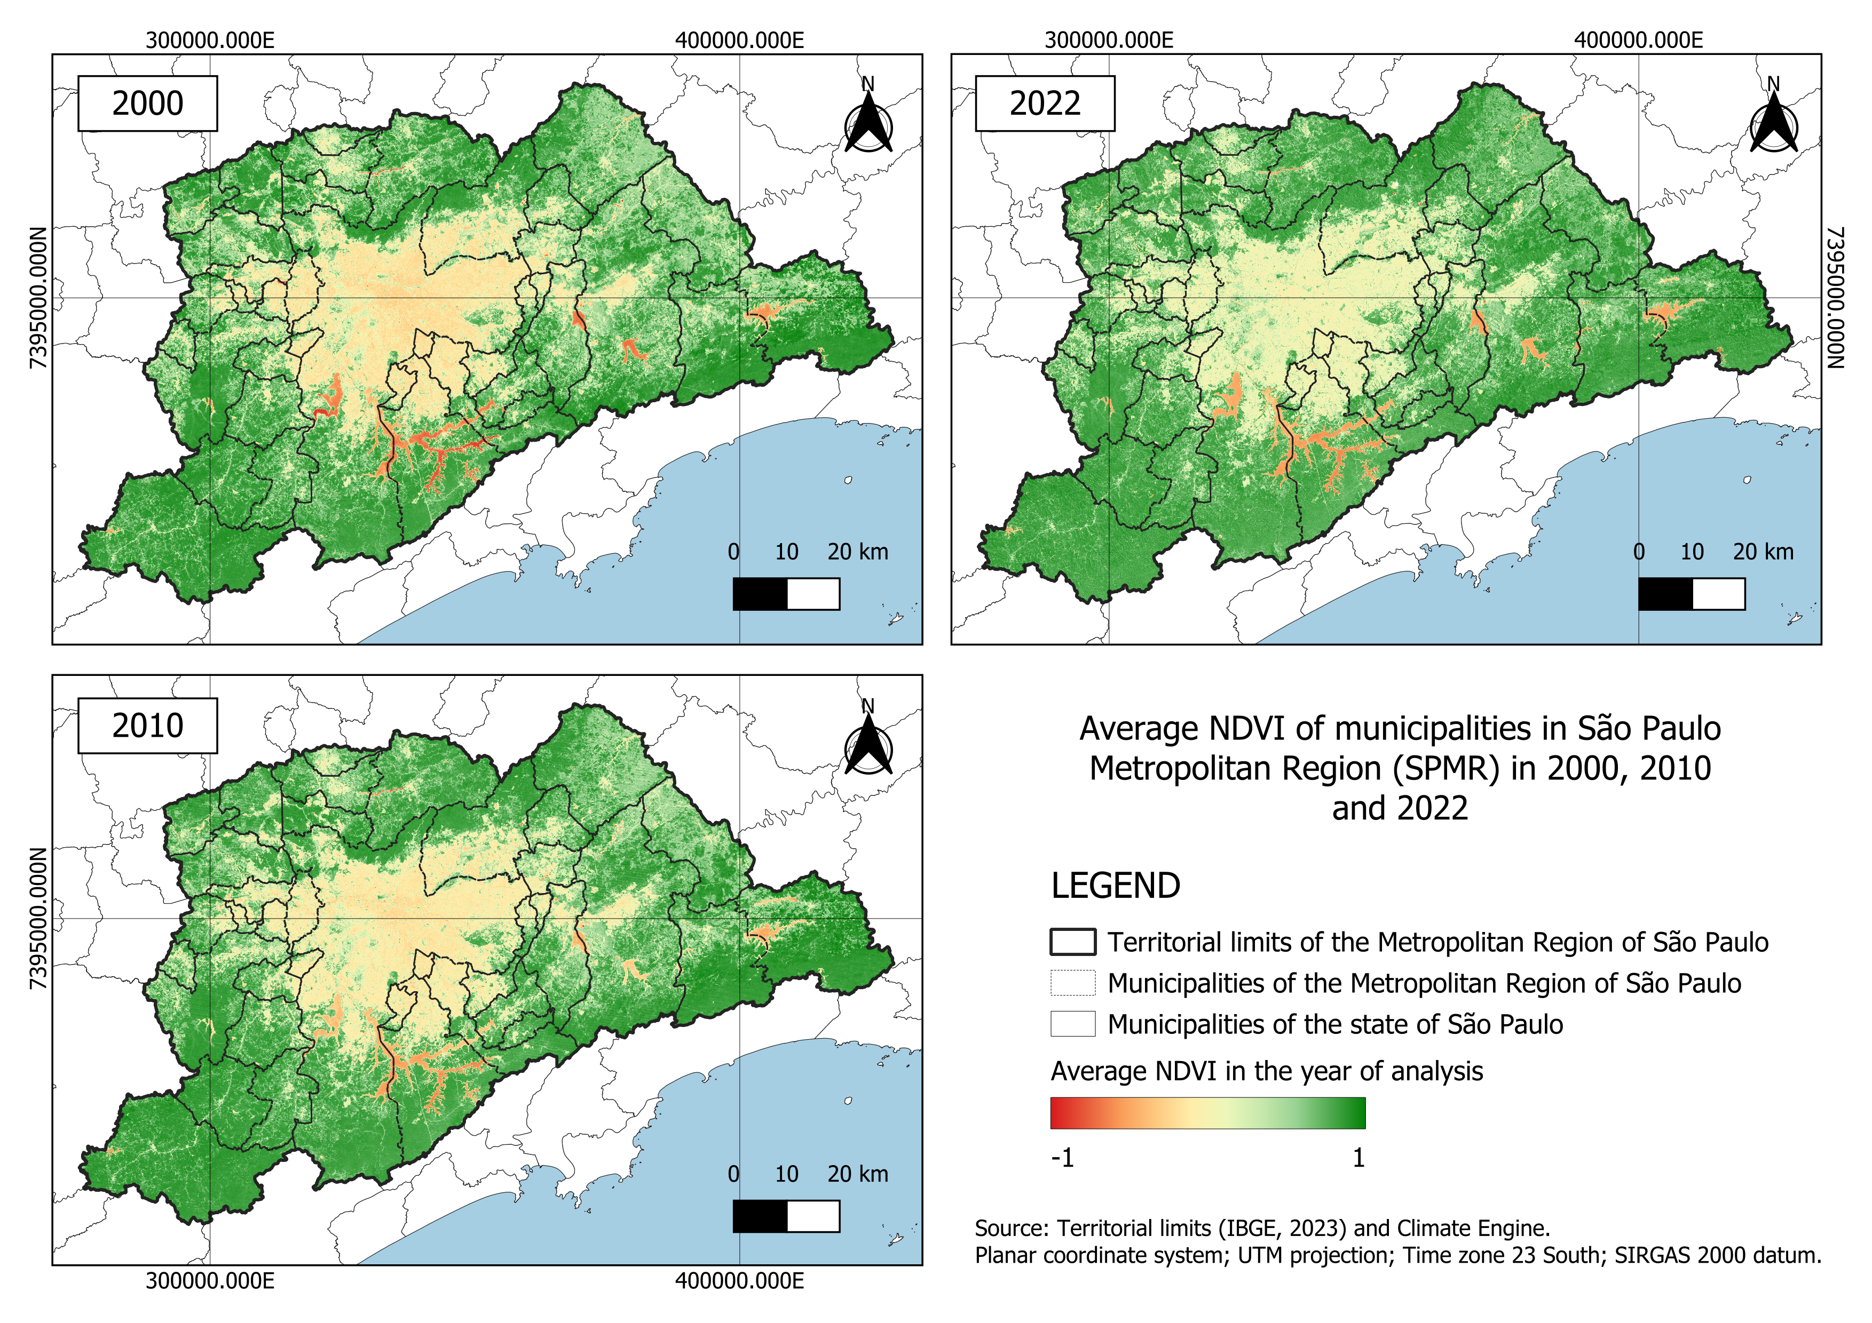

Source: The authors (2025).

Over the thirty years analyzed, the SPMR showed significant changes in mean NDVI that reflected the advance of urbanization. In the maps of 2000, 2010, and 2022 (Figure 5), a clear difference can be observed between central and peripheral areas: the municipalities of São Paulo, Guarulhos, Osasco, Santo André, São Bernardo do Campo, and Diadema recorded low mean NDVI (yellowish tones), indicating the replacement of native vegetation by buildings and infrastructure, while peripheral areas, especially in Cajamar, Franco da Rocha, Francisco Morato, and Mairiporã, maintained high values (green tones) due to remaining vegetation. Patches of low NDVI expanded over areas that previously had intermediate values, evidencing the direct impact of urban growth on vegetation cover. However, there were small punctual increases in NDVI associated with reforestation and protected areas created after 2000. These transformations lead to biodiversity loss and a reduction and a poor use of ecosystem services.

Figure 6 – Land use and land cover in SPMR for the years 2000, 2010, and 2022.

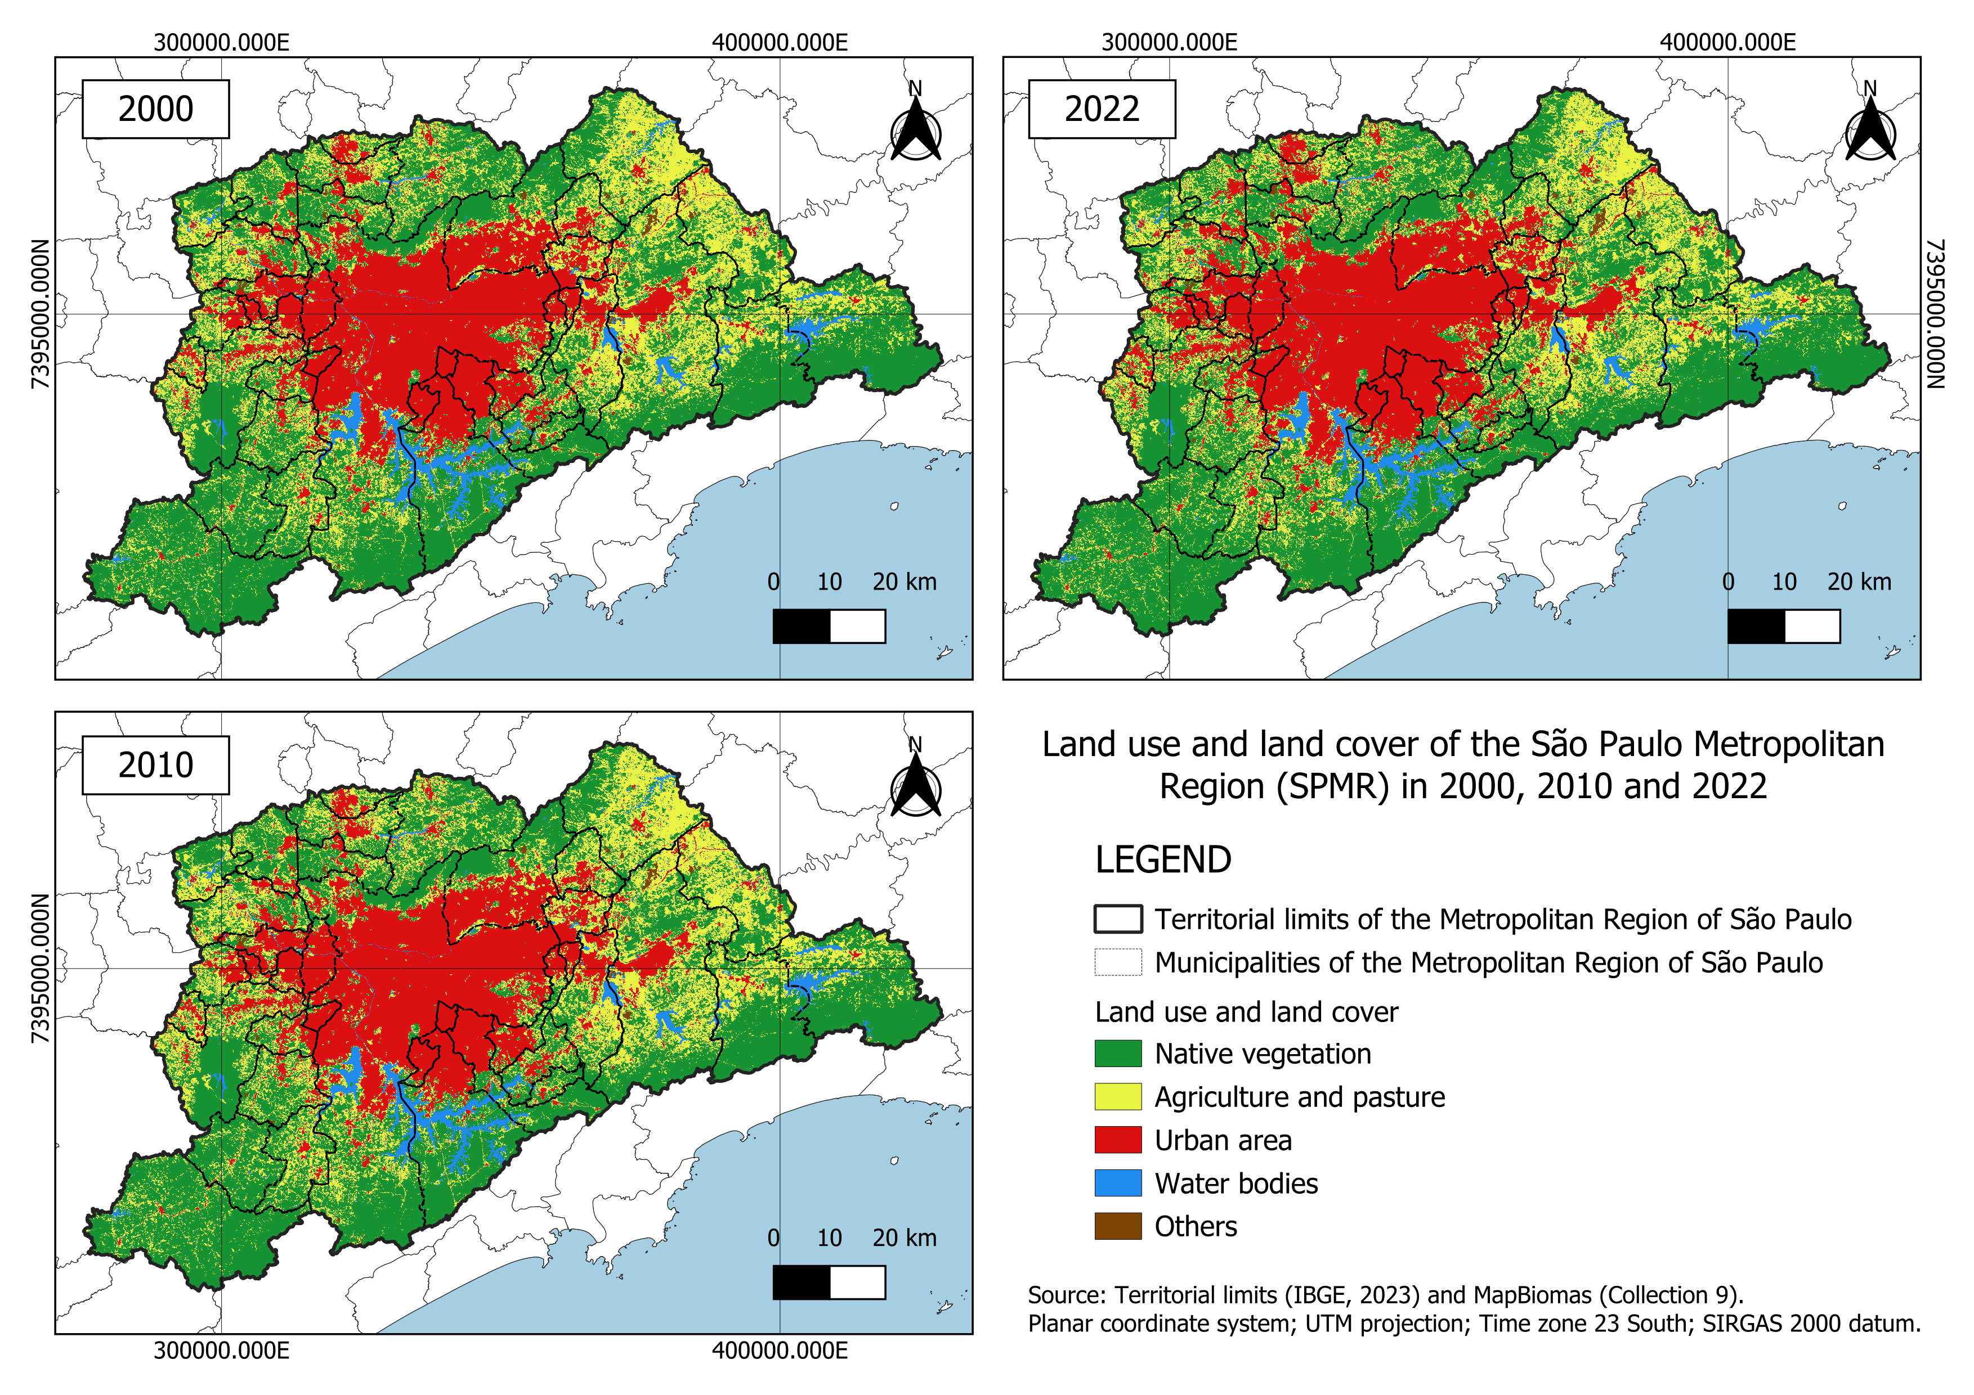

Source: The authors (2025).

The land use and land cover maps (Figure 6) show that in 2000, there was already a large continuous urban patch surrounded by mosaics of native vegetation and agricultural/pasture areas. In 2010 and 2022, this patch expanded and converted large agricultural parcels and even parts of native vegetation into urban areas, mainly in central municipalities such as São Paulo, Guarulhos, and Taboão da Serra. In peripheral municipalities (Mogi das Cruzes, Itapevi, São Lourenço da Serra), the reduction of agricultural areas is notable, indicating a transformation in land use. At the same time, environmental preservation areas such as Mairiporã, Cotia, and Juquitiba were able to preserve a significant portion of their vegetation due to conservation units and legal restrictions, although they continue to face pressure from urbanization.

The 2022 population density map (Figure 7) shows that the highest ranges (above 167 Inhab/ha) form a compact core in the heart of the SPMR, mainly in the São Paulo municipality and in their neighboring. Intermediate classes (47–167 Inhab/ha) form a belt around this core, and most of the region presents densities below 23 Inhab/ha (Figure 7). Densely populated areas are concentrated in São Paulo city and in adjacent municipalities (Guarulhos, Osasco, and Santo André); lighter tones, indicating lower densities, occur in more peripheral and rural zones, such as Mairiporã, Cotia, and Embu das Artes. This pattern highlights population concentration in central areas and along road axes, as observed by Jorge (1996), and reflects inequalities in occupation, with lower-quality housing coexisting with low-density, environmentally protected regions. The thresholds of 47 and 95 Inhab/ha used to stratify the analyses are justified by this distribution.

The results obtained are consistent with those of Pedrassoli (2016), who analyzed urban expansion in the SPMR over 30 years using satellite images and applied the linear spectral mixture model. The results demonstrated a significant intensification of urbanization in central municipalities, such as São Paulo, Guarulhos, Osasco, and Santo André, where built-up zones replaced areas of native vegetation and agricultural lands. This transformation led to an increase in impervious surfaces, exacerbating environmental issues such as flooding and heat islands, while also compromising the quality of life in these densely populated regions. In that same study, peripheral municipalities such as Mairiporã, Cotia, and Embu das Artes were identified as areas that still maintain significant vegetation remnants but suffer continuous threats to environmental preservation from new real estate developments. Pedrassoli (2016) also highlighted urban growth over agricultural and vegetated areas, especially in rural–urban transition zones.

### Qualitative results: correlation between NDVI and PD in SPMR in 2022

The scatterplot by population density classes (Graphic 1) and the correlation results obtained (Table 4) provide quantitative evidence of this relationship. In this sense, the statistical analysis of the relationship between population density and average NDVI in SPMR revealed distinct patterns according to the urban density level (POZZI; SMALL, 2002; ZHANG, F; *et al*., 2018).

In the low population density range (PD < 47 Inhab/Ha), which includes 101,460 samples, a strong negative correlation was observed between the variables. The Pearson coefficient was –0.605 (p = 0.000), indicating that in this range, an increase in density is significantly associated with a reduction in vegetation. This pattern is supported by the Spearman correlation (ρ = –0.469), also statistically significant (p = 0.000), suggesting a consistent monotonic inverse relationship even in the presence of possible nonlinearities. These results reflect the typical rural-to-urban transition process, where land occupation expands rapidly and vegetated areas are replaced by urban structures, resulting in a marked decline in NDVI (Seto et al., 2012).

In the medium population density range (47 ≤ PD < 95 Inhab/Ha), with 8,123 samples, the correlation between NDVI and population density becomes much weaker. The Pearson coefficient was –0.056 (p = 0.000) and the Spearman coefficient was –0.052 (p = 0.000), indicating a statistically significant but very weak negative correlation. This suggests that in this range, urban vegetation is relatively stabilized, consisting of sparse fragments such as parks, backyards, or institutional green areas. Changes in population density, therefore, have only a marginal effect on NDVI, as the vegetation cover is already limited and unevenly distributed (KABISCH *et al*., 2016).

Finally, in the high population density range (PD ≥ 95 Inhab/Ha), with 2,888 samples, the results indicate no significant correlation between the variables. The Pearson coefficient was –0.016 (p = 0.372), and the Spearman coefficient was nearly zero (ρ = 0.0008; p = 0.963). This lack of statistical association reflects an ecological saturation: in highly dense urban areas, such as the consolidated urban cores of the SPMR, NDVI values are uniformly low (≈ 0.15–0.35), and further increases in density do not lead to additional vegetation loss, since there is little to no green area left (YUAN; BAUER, 2007).

The 2010 results reproduce the non-linear pattern observed in 2022, but with important shifts in magnitude that help to read the trajectory of urbanization in the SPMR. In the low-density class (PD < 47 inhab/ha), the relationship strengthens over time: in 2010 the correlations were Pearson r = −0.4219 (p < 0.001) and Spearman ρ = −0.4691, whereas in 2022 they reach Pearson r = −0.6052 (p < 0.001) and Spearman ρ = −0.4698 (p < 0.001). This indicates that, on the urban fringe, each additional increment of population density in 2022 is associated with a steeper decline in vegetation than in 2010, consistent with the advance of built-up areas over vegetated land between the two dates.

In the medium-density class (47 ≤ PD < 95 inhab/ha), the opposite occurs: the association weakens markedly from 2010 to 2022. In 2010, Pearson r = −0.1714 (p < 0.001) and Spearman ρ = −0.1624 (p < 0.001) still captured a clear negative gradient; by 2022, the relationship fades to near-null values (Pearson r = −0.0559, p < 0.001; Spearman ρ = −0.0521, p < 0.001). This attenuation suggests consolidation of the urban fabric: vegetation is already scarce and fragmented in these areas, so further changes in density have only marginal effects on NDVI.

In the high-density class (PD ≥ 95 inhab/ha), the evidence points to saturation. In 2010, Pearson r = −0.0269 (p = 0.0031) and Spearman ρ = −0.0727 both indicate a very small, practically negligible relationship; by 2022 the association disappears entirely (Pearson r = −0.0166, p = 0.372; Spearman ρ ≈ 0.0009, p = 0.963). In other words, once densities are very high, NDVI remains uniformly low and no longer co-varies with population density.

Graphic 1 – Scatterplot resulting the correlation between NDVI and PD by density classes in 2022.

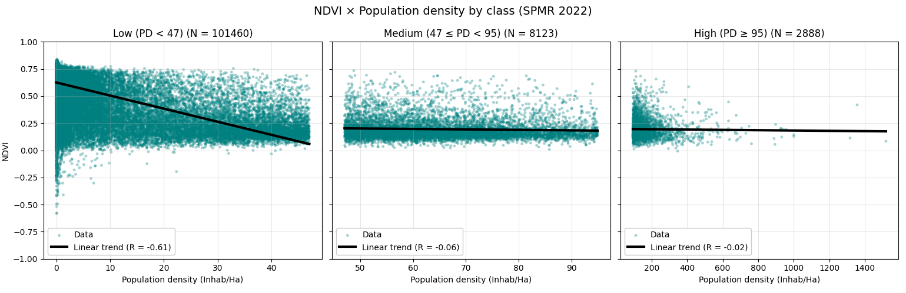

Source: The authors (2025).

Graphic 2 – Scatterplot resulting the correlation between NDVI and PD by density classes in 2010.

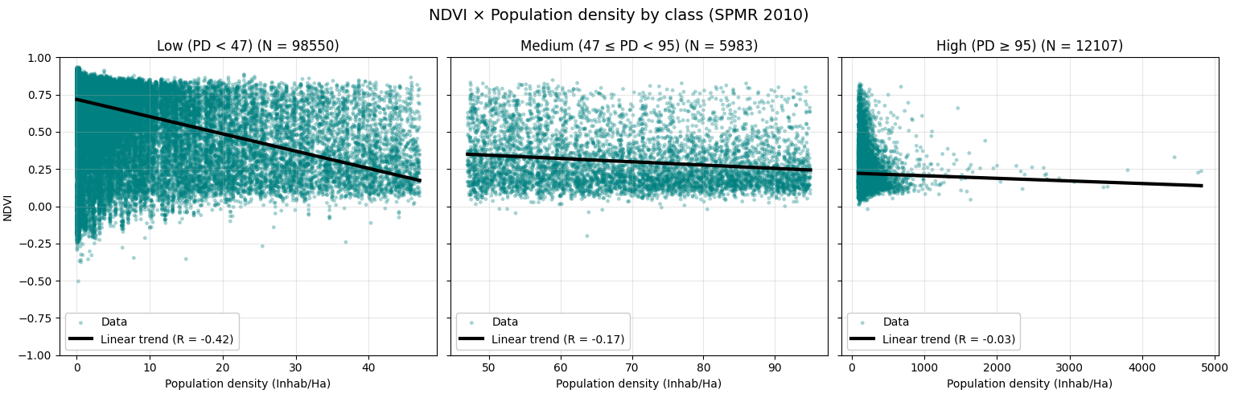

Source: The authors (2025).

The correlation table (Table 4) summarizes these patterns. It shows that a significant linear correlation only exists in the low-density class (p < 0.001), while in the medium- and high-density classes the coefficients are nearly null. Spearman’s coefficient reinforces that the relationship is monotonic only in the low-density class; in the others, residual vegetation behaves as a random variable in relation to density (PETTORELLI, 2013).

Table 4 - Correlations between mean NDVI and PD, stratified by density intervals in 2022.

| **Population density interval [Inhab/ha]** | **N** | ***Pearson_r*** | ***Pearson_p*** | ***Spearman_rho*** | ***Spearman_p*** |
| --- | --- | --- | --- | --- | --- |
| 2022 | | | | | |
| Low (PD < 47) | 101,460 | -0.605188 | 0.000000 | -0.469846 | 0.000000 |
| Medium (47 ≤ PD < 95) | 8,123 | -0.055887 | 0.000000 | -0.052106 | 0.000003 |
| High (PD ≥ 95) | 2,888 | -0.016603 | 0.372428 | 0.000860 | 0.963134 |
| 2010 | | | | | |
| Low (PD < 47) | 98,550 | -0.421880 | 0.000000 | -0.469907 | 0.000000 |
| Medium (47 ≤ PD < 95) | 5,983 | -0.171431 | 0.000000 | -0.162362 | 0.000003 |
| High (PD ≥ 95) | 12,107 | -0.026921 | 0.003052 | -0.072749 | 0.963134 |

Source: The authors (2025).

Taken together, these changes outline a clear temporal narrative. Between 2010 and 2022 the negative effect of densification becomes sharper where the urban front is still expanding (PD < 47), while the medium- and high-density belts converge toward a flat, saturated regime in which NDVI is already depressed and largely insensitive to further population increments. For planning, this means conservation and containment measures are most leverageable at the low-density fringe, incremental greening can still produce measurable gains in the medium-density belt, and retrofit-style nature-based solutions are the realistic pathway in the saturated high-density core.

To sum up, these results reinforce the idea that the relationship between NDVI and population density is strongly negative only during the initial stages of urban densification. Beyond a certain threshold, this relationship stabilizes, becoming statistically insignificant (YUAN; BAUER, 2007). This has direct implications for urban and environmental planning: low-density areas with still-high NDVI should be prioritized for conservation, while highly dense regions require mitigation strategies, such as tree planting and the implementation of green infrastructure, as the remaining vegetation is already in a critical or nonexistent state (BOWLER *et al*., 2010; DEMUZERE *et al*., 2014).

In general, the identified pattern reinforces the vegetation loss trend as population density increases. This relationship is consistent with and validates what was observed by Cerqueira and Gomes (2020) and Pedrassoli (2016). Pedrassoli (2016), for example, revealed a drastic reduction of native vegetation in areas of higher population density, especially along highways and transportation axes, which act as catalysts of urban expansion (Seto et al., 2012). This occurs because such dynamics are characteristic of urbanized areas, where population growth is often associated with the replacement of green areas by buildings, asphalt, and other impervious surfaces (YUAN; BAUER, 2007). Furthermore, other studies have also observed the same inversely proportional pattern in various metropolitan regions worldwide, as noted by Zhang *et al*. (2018), who identified this pattern in Chinese megacities.

### Green public policy development: high-priority zones map

The integrated spatial analysis of population density and NDVI variables made it possible to identify high-priority zones for public sustainability policies, as shown in the eligibility map (Figure 9). The clusters of red cells represent sectors where high population density coincides with low NDVI values; they are concentrated both in the central core and in some peripheral urban nuclei of the MRSP, characterizing areas where the lack of vegetation may negatively affect quality of life (temperature, psychological well-being, and physical health) (BOWLER *et al*., 2010). These critical areas indicate the need to create parks and squares in densely populated neighborhoods lacking green spaces, to encourage urban tree planting and the use of green roofs, and to preserve remaining fragments of native vegetation on urban fringes (DEMUZERE *et al*., 2014).

The most significant sustainability challenges are found in zones where former agricultural and pasture areas were converted into unplanned urbanization, resulting in very low NDVI values; on the other hand, regions that preserved native vegetation over the years maintain high NDVI levels and continue to function as metropolitan “lungs” (POZZI; SMALL, 2002). This historical comparison with land use reinforces the urgency of restoring vegetation in areas that underwent abrupt conversions.

In Figure 9, high-priority zones are densely clustered across the central municipalities of the SPMR, particularly São Paulo, Guarulhos, Osasco, and parts of the ABC Paulista, where urbanization and population density are highest (Seto et al., 2012).

Figure 9 – High-priority zones for the implementation of sustainable public policies in SPMR in 2022.

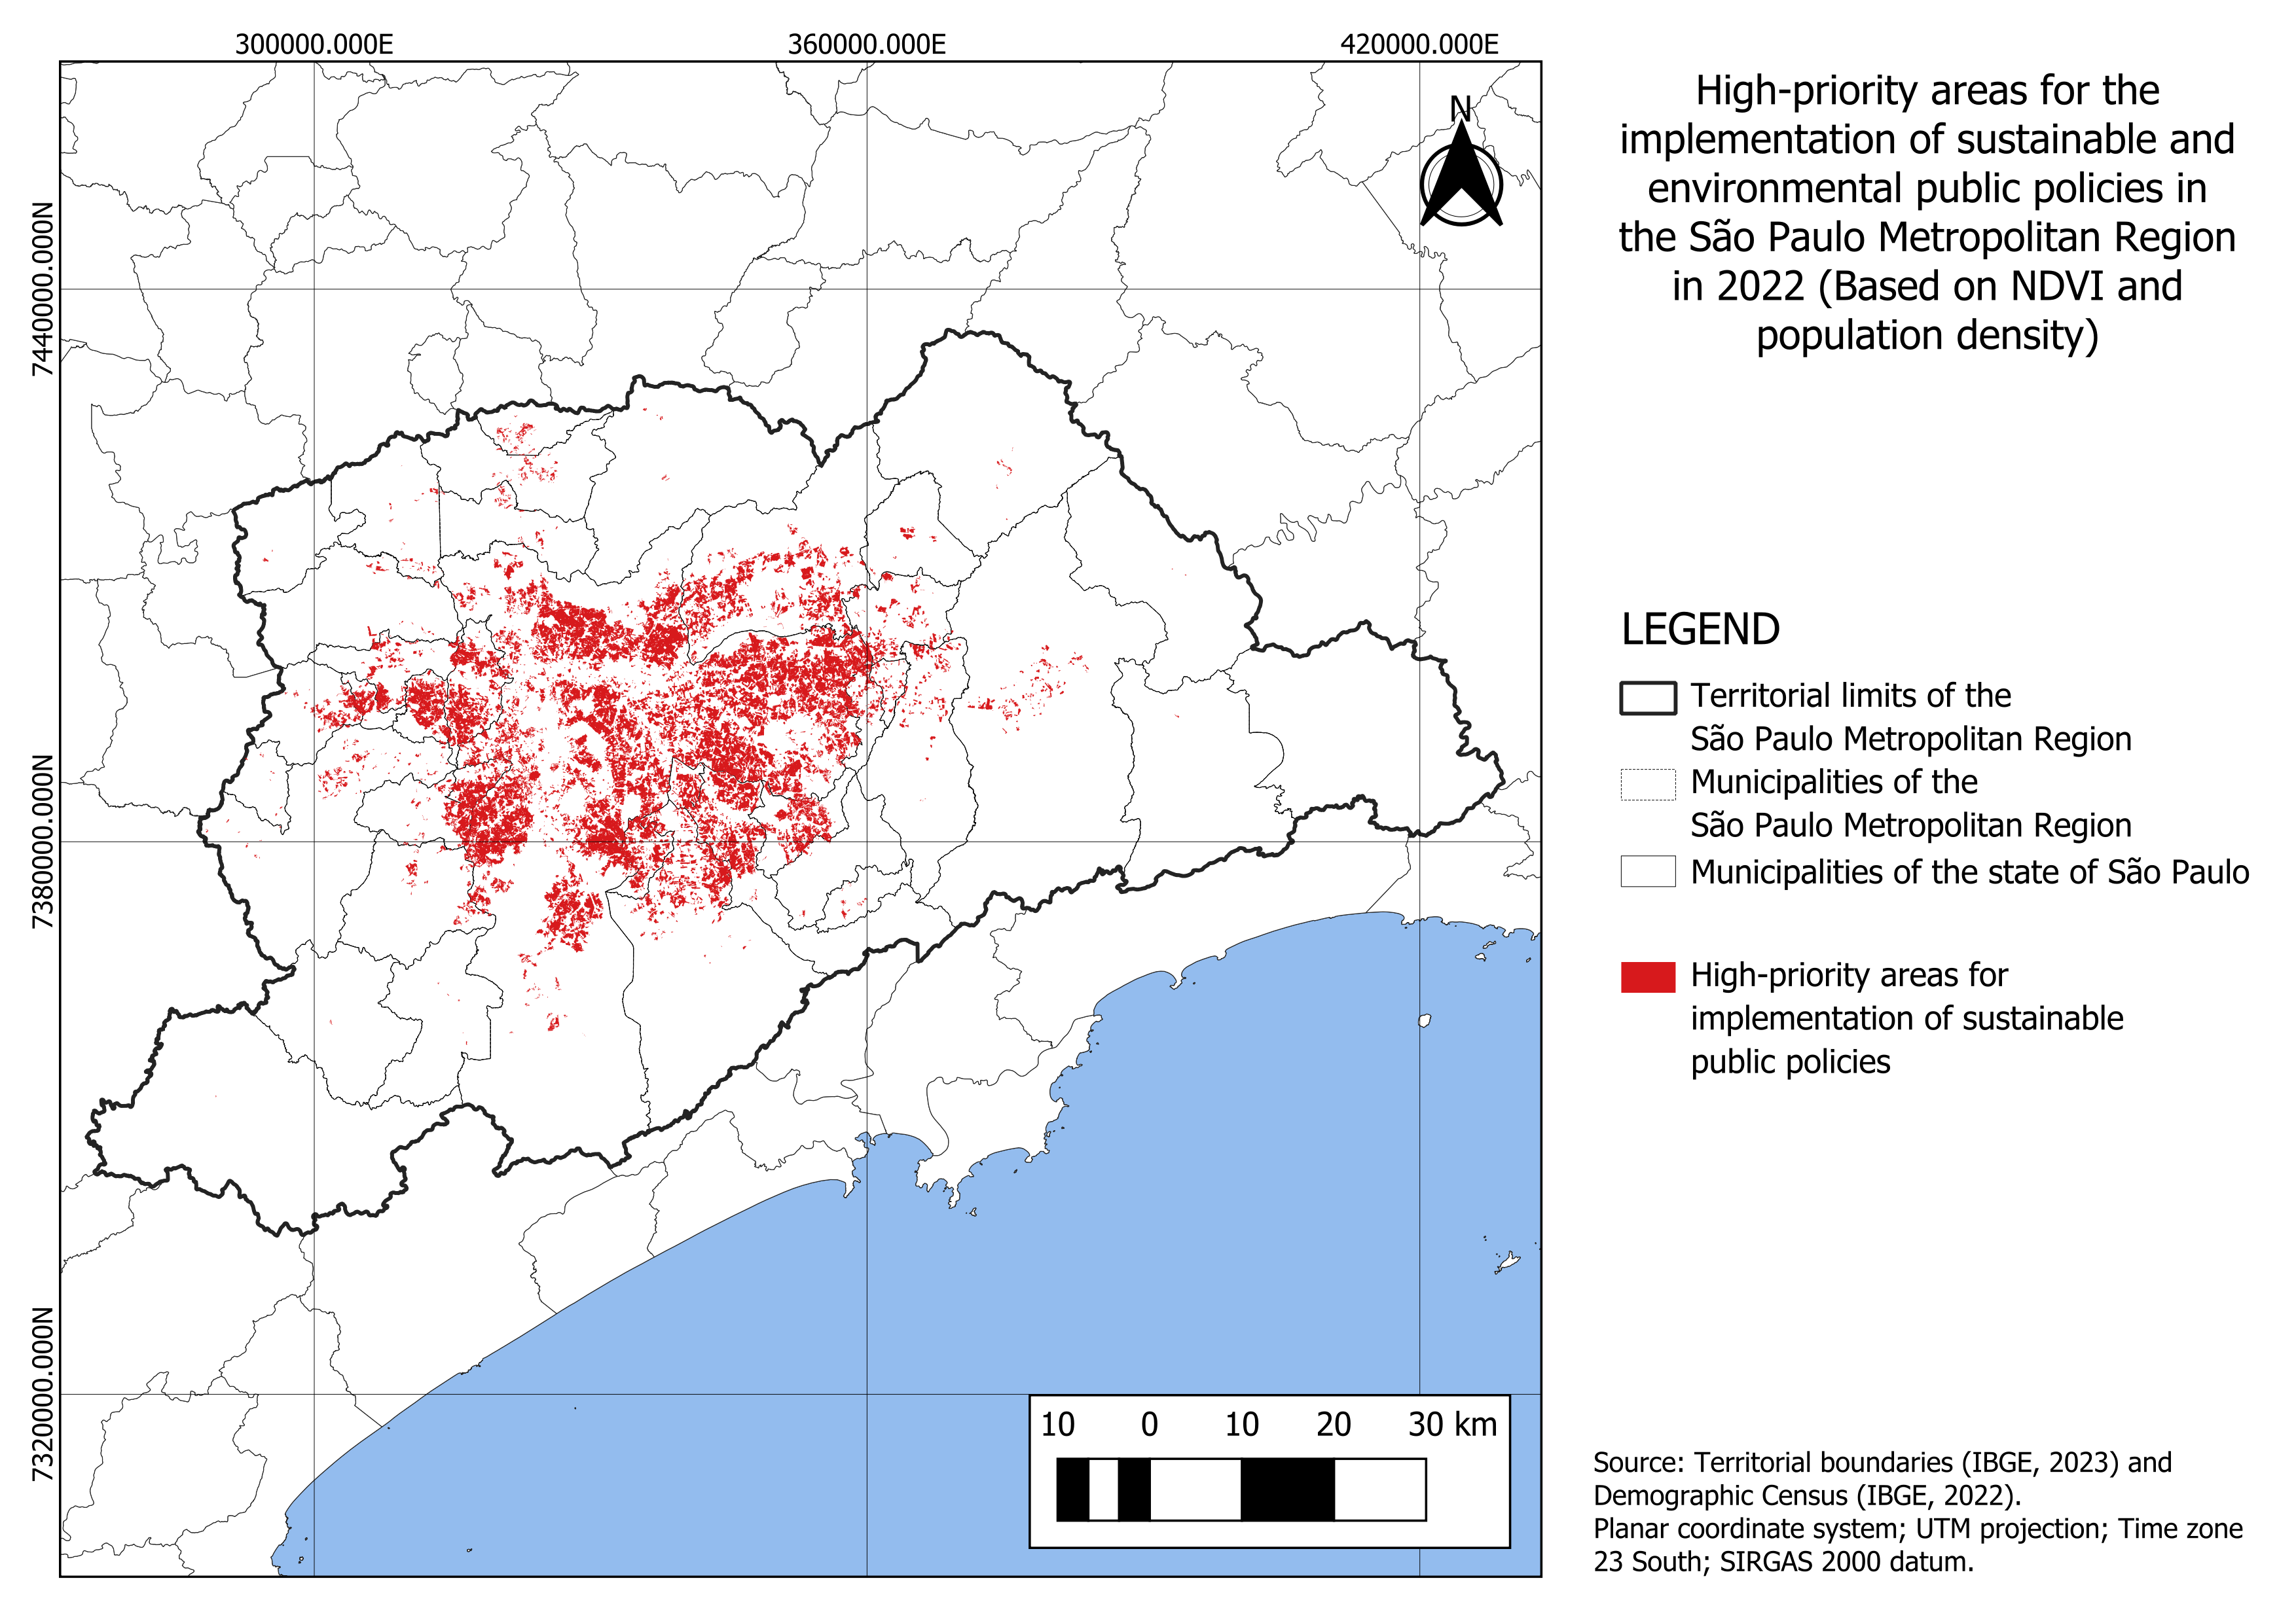

Source: The authors (2025).

Additional hotspots emerge in urbanized peripheries, notably in southern and eastern municipalities such as Itaquaquecetuba and Embu das Artes, which exhibit weaker infrastructure and greater environmental vulnerability, patterns consistent with unequal access to urban green space and socio-environmental risk in large cities (KABISCH *et al*., 2016). By contrast, municipalities farther from the metropolitan core, which are not highlighted in red, display lower population density and greater preservation of vegetation cover. Taken together, these patterns underscore the interdependence among population density, NDVI, and land-use history, thereby justifying the classification of these sectors as high-priority zones for the implementation of sustainability-oriented public policies (POZZI; SMALL, 2002).

Finally, the results reveal a non-linear relationship between vegetation and population density: green cover declines sharply during the initial stages of urban densification, but once a threshold of approximately 47 inhabitants/ha is surpassed, the association stabilizes and NDVI remains low regardless of further increases in density, consistent with plateaus observed under high impervious surface conditions (YUAN; BAUER, 2007).

# CONCLUSION

Vegetation plays an essential role in mitigating environmental impacts in urban areas, and its benefits become even more relevant in the face of challenges imposed by climate change, especially in densely populated regions such as the SPMR, which faces the effects of rapid urban expansion and demographic growth. In this context, this study investigated and validated the interdependence between population density and mean NDVI in SPMR, based on demographic and remote sensing data from the years 2000, 2010, and 2022. Remote sensing, geoprocessing, and artificial intelligence techniques were employed, including linear regression algorithms and machine learning methods. Furthermore, the study aimed to provide strategic support for the public sector, focusing on the development of sustainable urban planning and the identification of priority zones for implementing public policies and efficient resource allocation.

The integrated analysis of vegetation cover, population density, and land use in the SPMR between 2000, 2010, and 2022 revealed a clear trend of environmental degradation associated with urban expansion. NDVI maps showed that municipalities within the consolidated urban zone present persistently low values, while peripheral areas, especially those with topographic restrictions or under legal protection, still preserve significant vegetation cover. The progressive conversion of the agricultural regions and even native vegetation into urban zones, as observed in the land use maps, reinforces the continuous pressure on the region’s natural environment. The investigation of the relationship between NDVI and population density revealed nonlinear behavior. In low-density areas (PD < 47 Inhab/ha), a strong negative correlation was found, indicating that initial densification significantly reduces remaining vegetation. However, beyond this threshold, NDVI stabilizes at low levels, and the correlation within medium- and high-density ranges becomes practically null. This pattern characterizes a saturation process in which consolidated urbanization has already eliminated almost all vegetation, rendering further density increases environmentally irrelevant.

These findings justify the definition of specific thresholds for analysis (47 and 95 Inhab/ha) and the delimitation of priority intervention zones. Critical areas, located both in the metropolitan core and in expanding peripheries, combine high density and low vegetation, resulting in significant vulnerabilities to population health and well-being. Reversing this scenario requires planned actions tailored to the context of each densification range, such as the creation of urban parks, street tree planting, implementation of green roofs, and the recovery of vegetation fragments, particularly in densely populated neighborhoods.

In this sense, addressing these challenges requires investment in green infrastructure, restoration of degraded areas, and proper management of urban expansion. Urban planning must integrate housing, transportation, and environmental policies to balance urban growth with environmental preservation. Additionally, the protection of environmentally sensitive zones, through the creation of urban protected areas, reforestation, and land-use control, is fundamental to preventing further degradation and promoting sustainability. Future studies may also incorporate additional variables, such as detailed land-use and land-cover data, local public policies, and other demographic indicators, as well as cluster analyses that provide more precise information on regional patterns and support more effective interventions.

Therefore, this research demonstrates the relevance of remote sensing and geoprocessing techniques in analyzing the relationship between urbanization and vegetation and highlights the potential of artificial intelligence as a tool to accurately and efficiently identify patterns and critical areas. It is expected that the results presented here will contribute not only to a deeper understanding of this relationship in the SPMR but also to inspire public policies and future research aimed at promoting sustainable urban development, grounded in science and oriented toward environmental preservation and improved quality of urban life, ultimately contributing to the creation of greener, more resilient, and more inclusive cities.

# REFERENCES

Amato-Lourenço, L. F., Moreira, T. C. L., Arantes, B. L. de, Silva Filho, D. F. da, & Mauad, T. (2016). Metrópoles, cobertura vegetal, áreas verdes e saúde. *Estudos Avançados*, 30(86), 113-130. doi:10.1590/S0103-40142016.00100008

Arnfield, A. J. (2003). Two decades of urban climate research: A review of turbulence, exchanges of energy and water, and the urban heat island. *International Journal of Climatology*, 23(1), 1–26. https://doi.org/10.1002/joc.859

BAI, Y.; ZHANG, L.; CHEN, Y.; ZHANG, J. (2019). *Mapping the population density in mainland China using remote sensing and geospatial data*. Sustainability, v. 11, n. 13, p. 3616. DOI: 10.3390/su11133616.

BOWLER, D. E.; BUYUNG-ALI, L.; KNIGHT, T. M.; PULLIN, A. S. *Urban greening to cool towns and cities: a systematic review of the empirical evidence*. Landscape and Urban Planning, v. 97, n. 3, p. 147–155, 2010. DOI: 10.1016/j.landurbplan.2010.05.006.

Carvalho Júnior, O. A. de, Guimarães, R. G., Carvalho, A. P. F. de, Gomes, R. A. T., & Martins, E. de S. (2005). Considerações sobre o cálculo do coeficiente angular da regressão linear entre o espectro de referência e o espectro da imagem em mistura espectral. In *XII Simpósio Brasileiro de Sensoriamento Remoto* (pp. 4037–4044). São José dos Campos, SP: INPE.

Cerqueira, E. B., & Gomes, J. M. A. (2020). Análise do Índice de Vegetação por Diferença Normalizada nos municípios produtores de pó de carnaúba no Piauí e Ceará. *Geosul*, 35(76), 127–150. https://doi.org/10.5007/2177-5230.2020v35n76p127

DEMUZERE, M.; ORRU, K.; HEIDRICH, O.; OLAZABAL, E.; GENELETTI, D.; et al. *Mitigating and adapting to climate change: multi-functional and multi-scale assessment of green urban infrastructure*. Journal of Environmental Management, v. 146, p. 107–115, 2014. DOI: 10.1016/j.jenvman.2014.07.025.

Duarte, T. E. P. N., Angeoletto, F., Santos, J. W. M. C., da Silva, F. F., Bohrer, J. F. C., & Massad, L. (2018). Reflexões sobre arborização urbana: desafios a serem superados para o incremento da arborização urbana no Brasil. *Revista em Agronegócio e Meio Ambiente*, 11(1), 327-341.

Eastman, J. R., Sangermano, F., Machado, E. A., Rogan, J., & Anyamba, A. (2013). Global Trends in Seasonality of Normalized Difference Vegetation Index (NDVI), 1982–2011. *Remote Sensing*, 5(10), 4799-4818. https://doi.org/10.3390/rs5104799

EUROSTAT; JRC – EUROPEAN COMMISSION. (2011). *Degree of urbanization* (DEGURBA) – Methodological manual – 2011 edition. Luxembourg: Publications Office of the European Union. Available at: <https://ec.europa.eu/eurostat/web/products-manuals-and-guidelines/-/KS-RA-11-011>. Accessed on: Jul. 18. 2025.

Li, F., Song, G., Liujun, Z., Yanan, Z., & Di, L. (2017). Urban vegetation phenology analysis using high spatio-temporal NDVI time series. *Urban Forestry & Urban Greening*, 25, 43–57. https://doi.org/10.1016/j.ufug.2017.05.001

GUO, H.; et al. (2019). *Characterizing urban vegetation coverage and its spatial variation using high-resolution satellite imagery in Chinese cities*. Remote Sensing, v. 11, n. 3, p. 276.

Gupta, K., Kumar, P., Pathan, S. K., & Sharma, K. P. (2012). Urban Neighborhood Green Index – A measure of green spaces in urban areas. Landscape and Urban Planning, 105(3), 325–335. https://doi.org/10.1016/j.landurbplan.2012.01.003

Huntington, J. L., Hegewisch, K. C., Daudert, B., Morton, C. G., Abatzoglou, J. T., McEvoy, D. J., & Erickson, T. (2017). Climate Engine: Cloud Computing and Visualization of Climate and Remote Sensing Data for Advanced Natural Resource Monitoring and Process Understanding. *Bulletin of the American Meteorological Society*, *98*(11), 2397-2410. https://doi.org/10.1175/BAMS-D-15-00324.1

JORGE, W. E.; SALGADO, E. C. O. *Alterações na estrutura urbana da região metropolitana de São Paulo*. Pós - Revista do Programa de Pós-Graduação em Arquitetura e Urbanismo da FAUUSP, São Paulo, v. 6, p. 154-163, dez. 1996.

Junttila, V., & Laine, M. (2017). Bayesian principal component regression model with spatial effects for forest inventory variables under small field sample size. Remote Sensing of Environment. https://doi.org/10.1016/j.rse.2017.01.035

KABISCH, N.; STROHBACH, M.; HAASE, D.; KRONENBERG, J. *Urban green space availability in European cities*. Ecological Indicators, v. 70, p. 586–596, 2016. DOI: 10.1016/j.ecolind.2016.02.029.

Li, G., & Weng, Q. (2007). Measuring the quality of life in city of Indianapolis by integration of remote sensing and census data. International Journal of Remote Sensing, 28(2), 249–267. https://doi.org/10.1080/01431160600735624

Santos, A. M., Holmes, D. C. de S. C., & Ramos, H. F. (2018). Densidade demográfica: um estudo comparativo de duas metodologias a partir de imagens orbital e suborbital na cidade de Aparecida de Goiânia/Goiás. *Ateliê Geográfico*, 12(1), 175–200. https://doi.org/10.5216/ag.v12i1.45968

De La Iglesia Martinez, A., & Labib, S. M. (2023). Demystifying normalized difference vegetation index (NDVI) for greenness exposure assessments and policy interventions in urban greening. *Environmental Research*, 220, 115155. https://doi.org/10.1016/j.envres.2022.115155

McDonald, R. I., Kareiva, P., & Forman, R. T. T. (2008). The implications of current and future urbanization for global protected areas and biodiversity conservation. *Biological Conservation*, 141(6), 1695–1703. https://doi.org/10.1016/j.biocon.2008.04.025

Nobre, C. A., Young, A. F., & Saldiva, P. (2011). Vulnerabilidades das megacidades brasileiras às mudanças climáticas: Região Metropolitana de São Paulo – Relatório final (pp. 0–186). Unicamp. https://www.nepo.unicamp.br/publicacoes/relatorio-final/megacidades_RMSP.pdf

Martins, R. D.. (2009). População e mudança climática: dimensões humanas das mudanças ambientais globais. *Ambiente & Sociedade*, 12(2), 399–403. https://doi.org/10.1590/S1414-753X2009000200014

Oke, T. R. (1982). The energetic basis of the urban heat island. *Quarterly Journal of the Royal Meteorological Society*, 108(455), 1–24. https://doi.org/10.1002/qj.49710845502

PEDRASSOLI, J. C. *Habitação e sensoriamento remoto: uma análise da expansão urbana na RMSP por meio de imagens de satélite aplicando o modelo linear de mistura espectral*. 2016. Tese (Doutorado) – Universidade de São Paulo, São Paulo, 2016. Available at: <http://www.teses.usp.br/teses/disponiveis/8/8136/tde-13022017-124413/>. Accessed on: Jul. 25. 2025.

PETTORELLI, N. *The Normalized Difference Vegetation Index (NDVI)*. Oxford: Oxford University Press, 2013.

Ponzoni, F. J., Shimabukuro, Y. E., & Kuplich, T. M. (2012). Sensoriamento remoto da vegetação (2ª ed., atualizada e ampliada). Oficina de Textos.

POZZI, F.; SMALL, C. (2002). Vegetation and population density in urban and suburban areas in the USA. International Journal of Remote Sensing, v. 23, n. 4, p. 673–685. DOI: 10.1080/01431160010006923.

Ribeiro, M. C., Metzger, J. P., Martensen, A. C., Ponzoni, F. J., & Hirota, M. M. (2009). The Brazilian Atlantic Forest: How much is left, and how is the remaining forest distributed? Implications for conservation. *Biological Conservation*, 142(6), 1141–1153. https://doi.org/10.1016/j.biocon.2009.02.021

Seto, K. C., Güneralp, B., & Hutyra, L. R. (2012). Global forecasts of urban expansion to 2030 and direct impacts on biodiversity and carbon pools. *Proceedings of the National Academy of Sciences*, 109(40), 16083–16088. https://doi.org/10.1073/pnas.1211658109

Sharma, S., Beslity, J. O., Rustad, L., Shelby, L. J., Manos, P. T., Khanal, P., Reinmann, A. B., & Khanal, C. (2024). Remote sensing and GIS in natural resource management: Comparing tools and emphasizing the importance of in-situ data. *Remote Sensing*, 16(22), 4161. https://doi.org/10.3390/rs16224161

Sun, J., Wang, X., Chen, A., Ma, Y., Cui, M., & Piao, S. (2011). NDVI indicated characteristics of vegetation cover change in China’s metropolises over the last three decades. Environmental Monitoring and Assessment, 179, 1–14. https://doi.org/10.1007/s10661-010-1715-x

TUCKER, C. J. (1979). *Red and photographic infrared linear combinations for monitoring vegetation*. Remote Sensing of Environment, v. 8, n. 2, p. 127–150.

UNITED NATIONS STATISTICAL COMMISSION (UNSTAT). (2017). A Recommendation on the Method to Delineate Cities, Urban and Rural Areas for International Statistical Comparisons. Available at: <https://unstats.un.org/unsd/statcom/51st-session/documents/BG-Item3j-Recommendation-E.pdf>. Accessed on: Jul. 25. 2025.

WEIER, J.; HERRING, D. (2000). *Measuring vegetation (NDVI & EVI)*. NASA Earth Observatory. Available at: <https://earthobservatory.nasa.gov/features/MeasuringVegetation>. Accessed on: Jul. 24. 2025.

Xavier, R. L., Menezes, D. B., & Silva, F. L. (2024). Mapeamento de uso e ocupação do solo utilizando dados do MapBiomas: uma abordagem manual para aumento de precisão aplicada em Meridiano, São Paulo. *Revista Brasileira de Geografia Física*, 17(3), 1992–2007.

Yuan, F., & Bauer, M. E. (2007). Comparison of impervious surface area and normalized difference vegetation index as indicators of surface urban heat island effects in Landsat imagery. *Remote Sensing of Environment*, 106(3), 375–386. https://doi.org/10.1016/j.rse.2006.09.003

ZHANG, F.; DU, B.; ZHANG, L. *A multi-task convolutional neural network for mega-city analysis using very high-resolution satellite imagery and geospatial data*. ISPRS Journal of Photogrammetry and Remote Sensing, v. 146, p. 349-364, 2018. DOI: 10.1016/j.isprsjprs.2018.10.010.

Moravec, D., Komárek, J., López-Cuervo Medina, S., & Molina, I. (2021). Effect of Atmospheric Corrections on NDVI: Intercomparability of Landsat 8, Sentinel-2, and UAV Sensors. Remote Sensing, 13(18), 3550. https://doi.org/10.3390/rs13183550

## Acknowledgments

I would like to express my sincere gratitude to the Federal University of ABC (UFABC) for the institutional support and essential resources that made this work possible. I am especially thankful to the academic staff, research offices, and laboratory teams whose assistance with logistics, infrastructure, and computing resources greatly facilitated the development of this study.

To my co-author, particularly my advisors and professor, my deepest thanks for your guidance, insightful feedback, and sustained encouragement throughout every stage of the research. Your scientific rigor, generosity with time, and collaborative spirit were fundamental to shaping the questions, methods, and interpretations presented here. I am also grateful to colleagues and peers who contributed through discussions, code review, and thoughtful comments on earlier drafts.

## Authors’ contributions

This work benefited from the complementary contributions of its authors to the development and quality of the research. Bruno Zomignani Perciani, an undergraduate student at the Federal University of ABC (UFABC) and the primary author, was responsible for several key stages, including the initial conceptualization of the study, the development and application of the methodology, the investigation process, the formal data analysis, and the drafting of the initial manuscript. He also produced visual materials, such as graphs and maps, which supported the interpretation and presentation of the results. In addition, UFABC faculty member and co-author Dr. Victor Fernandez Nascimento played an important role, providing supervision, technical and intellectual support, and contributing to the refinement of the methodological approach. They also participated in a careful, critical review of the manuscript, ensuring the accuracy of the concepts and analyses to maintain the scientific rigor, originality, and overall quality of the final study.

## Conflicts of interest

I declare that there were no conflicts of interest during the execution of this work. All stages of the research were conducted transparently and impartially, with full commitment to ethics and scientific integrity.

# BIOGRAPHY OF THE FIRST AUTHOR

|  |  |
| --- | --- |
|  | Bruno Zomignani Perciani was born in Jundiaí, São Paulo, Brazil. He holds a technical degree in Plastics from SENAI Conde Alexandre Siciliano, in Jundiaí, and is currently pursuing a Bachelor of Science and Technology at the Federal University of ABC (UFABC). In 2022, he received the Lavoisier Award from the Regional Chemistry Council (IV Region), as well as the FIRST Dean’s List Finalist Award in 2022 at the FIRST Robotics Competition regional tournament held in San Francisco, California, United States. His academic interests include geospatial analysis, and data-driven approaches to sustainability. |

 Esta obra está licenciada com uma Licença [Creative Commons Atribuição 4.0 Internacional](https://creativecommons.org/licenses/by/4.0/) – CC BY. Esta licença permite que outros distribuam, remixem, adaptem e criem a partir do seu trabalho, mesmo para fins comerciais, desde que lhe atribuam o devido crédito pela criação original.